‘Students achieving their full potential as active thinkers and self-motivated, life-long learners

within a supportive environment’.

**CES NEWS**

**Follow us on Instagram: @Cambridgemangafkw**

**Term: 1 Week: 5 2nd October 2022**

**DATES FOR THE DIARY:**

**Special Assembly:** Thursday 6th October 2022 at 7.15am in the Quad (Pupils only)

**Cancer Awareness Week:** 9th—13th October 2022

**Pink Day: 13th October 2022**. This is a non-uniform day and children can come to school wearing pink or blue to help raise awareness for cancer.

**PRIMARY**

**BULLETON:**

& We want children to love learning in Primary and to enjoy their weekends. This is why we will send homework out on Sundays instead of Thursdays from now on.

& Parents. Do please dedicate some time in the day to read with your child. Just 5 minutes a day can make such a big difference.

**Attendance**

**Target is:**

**100%**

](https://www.instagram.com/cambridge.e.s.kw/)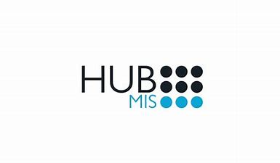

**Term: 1 Week: 10 10th November 2022**

**http://www.cambridge-kw.com/**

**Follow us on Instagram: @Cambridgemangafkw**

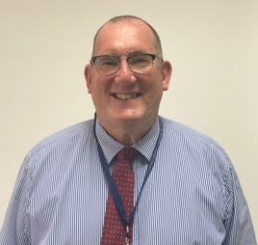

Next week is our whole school Anti-Bullying Week!

The theme of Anti-Bullying Week this year is **Reach Out**. Anti-Bullying Week will remind everyone whether it’s in school, at home, in the community or online, let’s reach out and show each other the support we need. We are asking all children to **wear a pair of odd socks** on **Thursday 17th November** to support our effort in celebrating uniqueness.

A message from

**Mr John**

Principal

Dear Parents,

I hope this finds you all well and looking forward to having your children home next week.

It has been a very busy start to the year, and it is good to have clubs back, and the first trips being planned!

Our roll continues to grow, and our school is a vibrant and busy place.

This week we have selected prefects for our Primary and Secondary Schools. I was very impressed by the quality of our students, and their willingness to give back to their school. They are all proud to be students of CES Mangaf!

As we enter flu season, I would ask that you keep your child home from school if they have a temperature or feel generally unwell.

Thank you for your efforts on attendance and punctuality. They are improving!

Enjoy the cooler weather and the break from school next week.

A date for your calendar is Thursday 10th November, which will be a chance to meet your child’s teachers and discuss their progress.

Thank you for your continued support.

A message from

**Ms. Walaa**

Head of Islamic

Change image to Ms Walaa and get walaa to write something here

A message from

**Mr. Fouad**

Head of Arabic

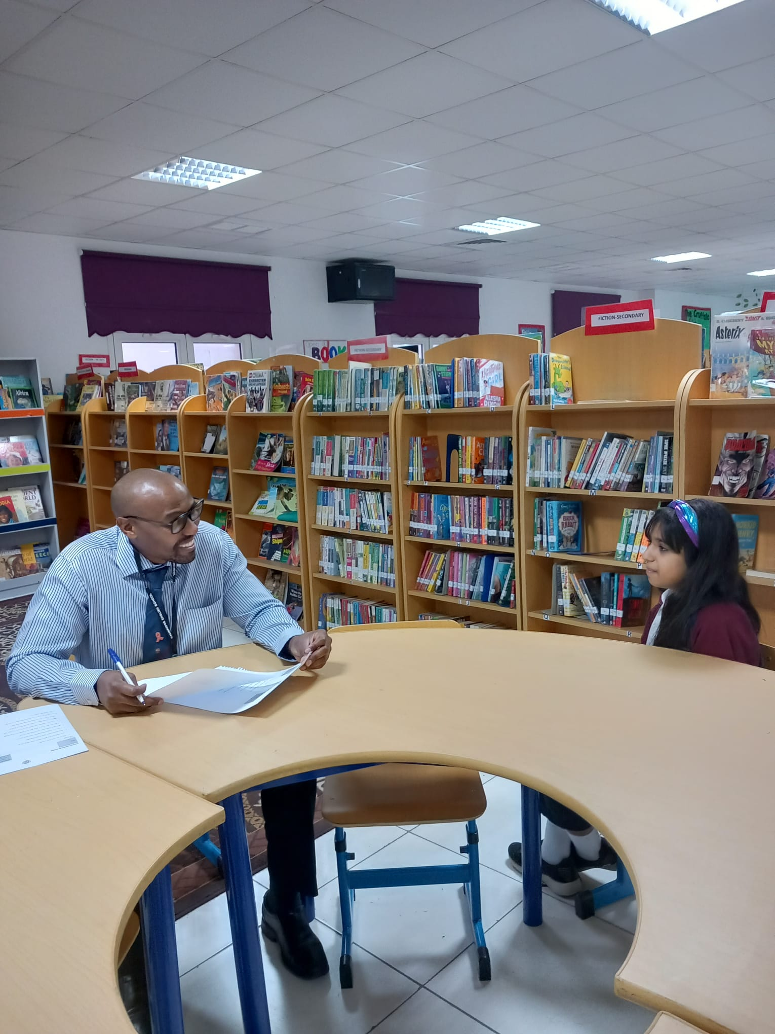

Change image to Mr Fouad and get Mr Fouad to write something here.

**WEEKLY ATTENDANCE**

**CES Mangaf Attendance**

**Target is:**

**100%**

**Congratulations**

**to: Rec Blue, 1 Blue, 2 Blue,**

**2 Red, 4 Green, 5 Red and 10EO for highest class attendance week ending 13.10.2022**

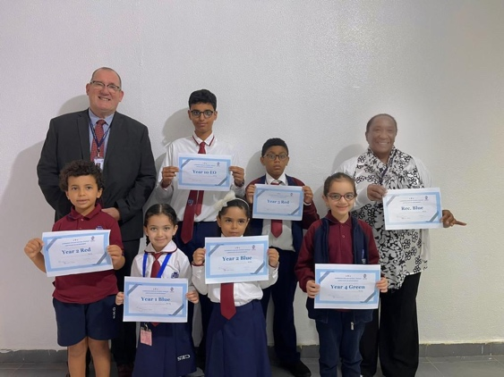

CES Mangaf school Attendance for Week ending: 13.10.2022

**90%**

‘Students achieving their full potential as active thinkers and self-motivated, life-long learners

within a supportive environment’.

**CES NEWS**

**Follow us on Instagram: @Cambridgemangafkw**

**Term: 1 Week: 5 2nd October 2022**

**DATES FOR THE DIARY:**

**Special Assembly:** Thursday 6th October 2022 at 7.15am in the Quad (Pupils only)

**Cancer Awareness Week:** 9th—13th October 2022

**Pink Day: 13th October 2022**. This is a non-uniform day and children can come to school wearing pink or blue to help raise awareness for cancer.

**PRIMARY**

**BULLETON:**

& We want children to love learning in Primary and to enjoy their weekends. This is why we will send homework out on Sundays instead of Thursdays from now on.

& Parents. Do please dedicate some time in the day to read with your child. Just 5 minutes a day can make such a big difference.

**Attendance**

**Target is:**

**100%**

|  |
| --- |
| A message from:  **Ms. Aya**  Headteacher of Primary  It was so lovely to see lots of parents attend our Parents into Planting workshop with the EYFS children. Thank you to everyone involved in making this day a success and for wearing the colour green. We are sure the children got a lot out of this collaborative session.  A group of girls posing for a picture  Description automatically generated with low confidence A group of people in a room  Description automatically generated with medium confidence  **DATES FOR THE DIARY:**  **Half term Holiday:** School photos are starting next week from Sunday 13th until Thursday 17th November. Please make sure your child attends school every day so not to miss the photos and ensure your child is wearing their correct school uniform.  **Anti-Bullying Week:** From Sunday 13th – Thursday 17th November. Please make sure your child is in school before 7.15am so not to miss the special assemblies that will take place straight after flag raising. We will also encourage all students and staff to wear odd socks on Thursday 17th November to celebrate being unique.  **Thursday 24th November:** School will be closed to pupils on this day to allow for our staff to have a INSET day (this is a day where teachers receive training). |

](https://www.instagram.com/cambridge.e.s.kw/)



It’s been a very busy week in our secondary school.

Our seniors were interviewed for student leadership positions,

whilst nominations and voting took place for the student council.

The standard of the applications and interviews was excellent and

winners will be announced very soon.

A message from:

**Mr. Andy**

Headteacher of Secondary

**http://www.cambridge-kw.com/**

**Follow us on Instagram: @Cambridgemangafkw**

**Term: 1 Week: 10 10th November 2022**