‘Students achieving their full potential as active thinkers and self-motivated, life-long learners

within a supportive environment’.

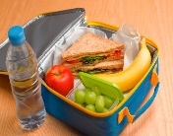

**CES NEWS**

**Follow us on Instagram: @Cambridgemangafkw**

**Term: 1 Week: 5 2nd October 2022**

**DATES FOR THE DIARY:**

**Special Assembly:** Thursday 6th October 2022 at 7.15am in the Quad (Pupils only)

**Cancer Awareness Week:** 9th—13th October 2022

**Pink Day: 13th October 2022**. This is a non-uniform day and children can come to school wearing pink or blue to help raise awareness for cancer.

**PRIMARY**

**BULLETON:**

& We want children to love learning in Primary and to enjoy their weekends. This is why we will send homework out on Sundays instead of Thursdays from now on.

& Parents. Do please dedicate some time in the day to read with your child. Just 5 minutes a day can make such a big difference.

**Attendance**

**Target is:**

**100%**

](https://www.instagram.com/cambridge.e.s.kw/)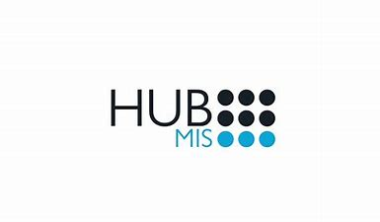

**Term: 1 Week: 11 17th November 2022**

**http://www.cambridge-kw.com/**

**Follow us on Instagram: @Cambridgemangafkw**



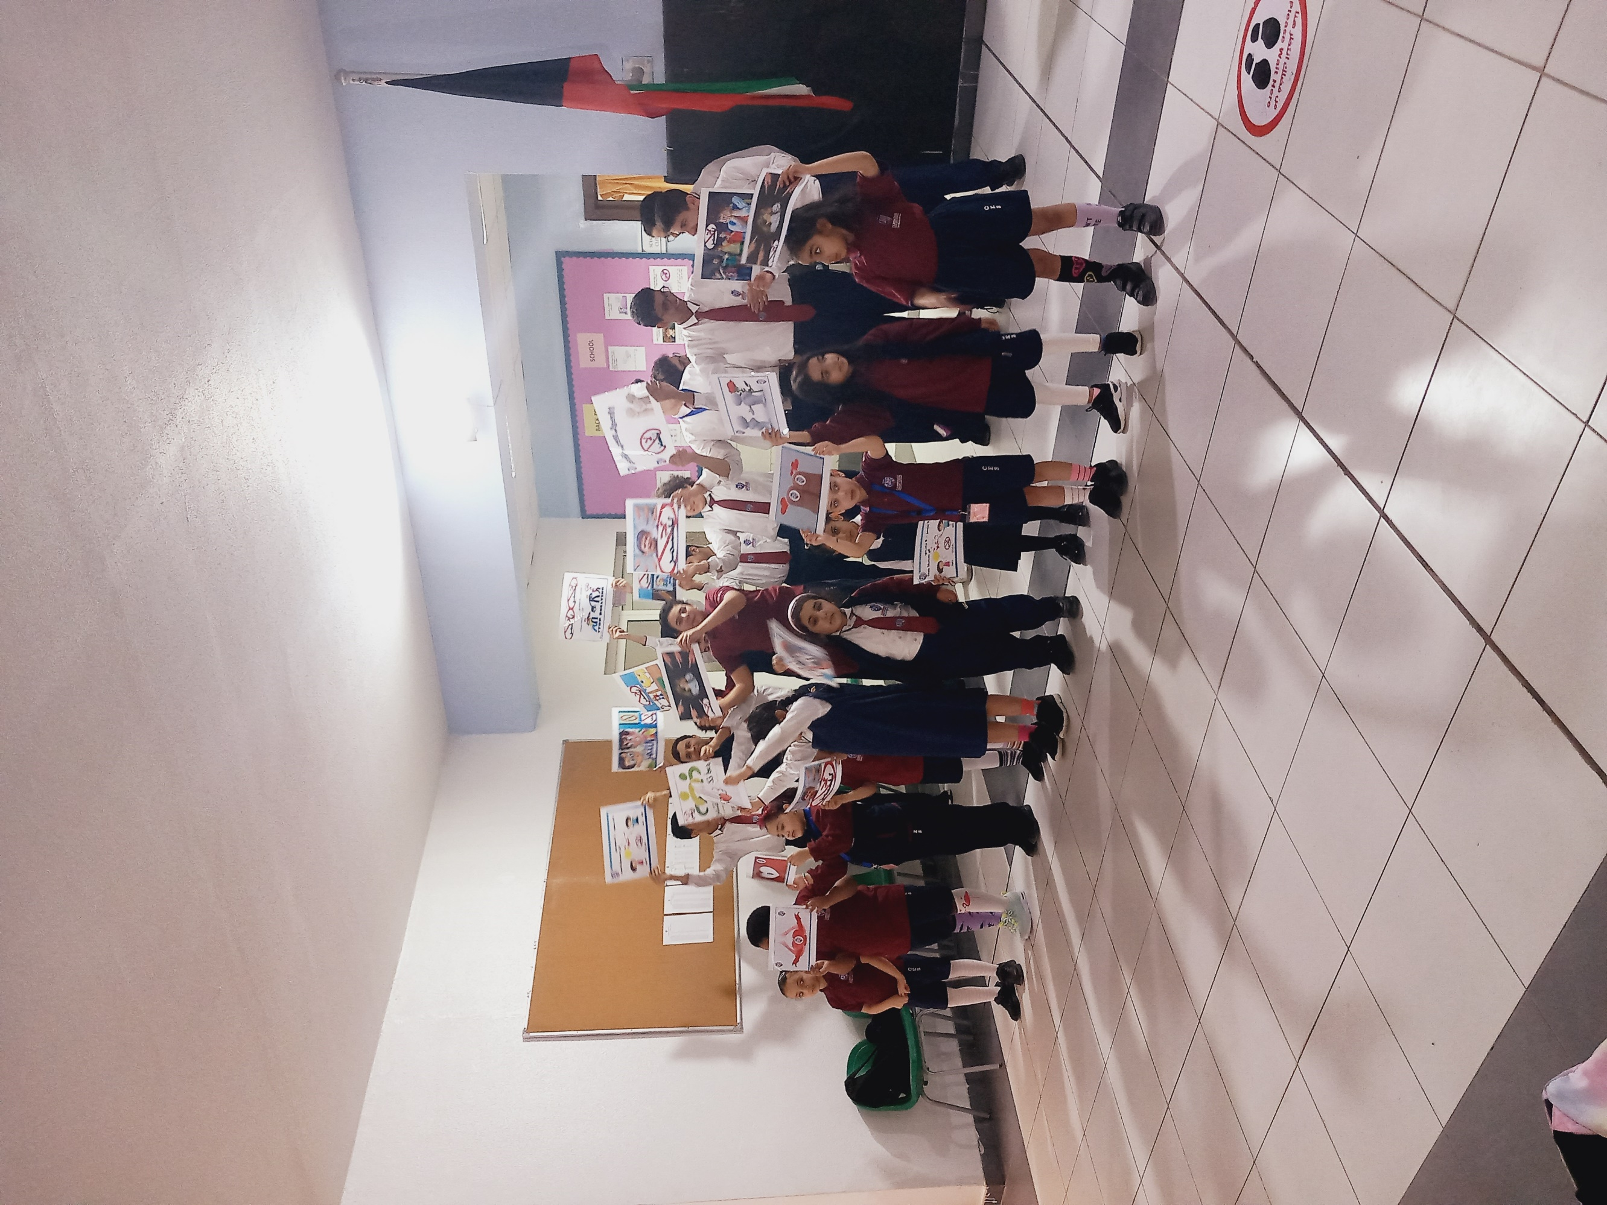

A message from

**Mr John**

Principal

Dear Parents,

It has been a very busy week at CES, Mangaf and I have particularly enjoyed the special assemblies to do with Anti-Bullying. It was great to hear the students speaking and sharing their songs and powerful messages from KG all the way up to our Senior students. A huge thank you to everyone involved in making this enrichment week a fantastic one! Now, let us all work together to make Cambridge English School a kinder community!

It was lovely to hear about the School Council meeting that took place earlier this week with students who have been chosen to represent their classes throughout the school. I look forward to hearing their ideas about how we can further improve the school.

Thank you for your continued support.

**COMPETITION**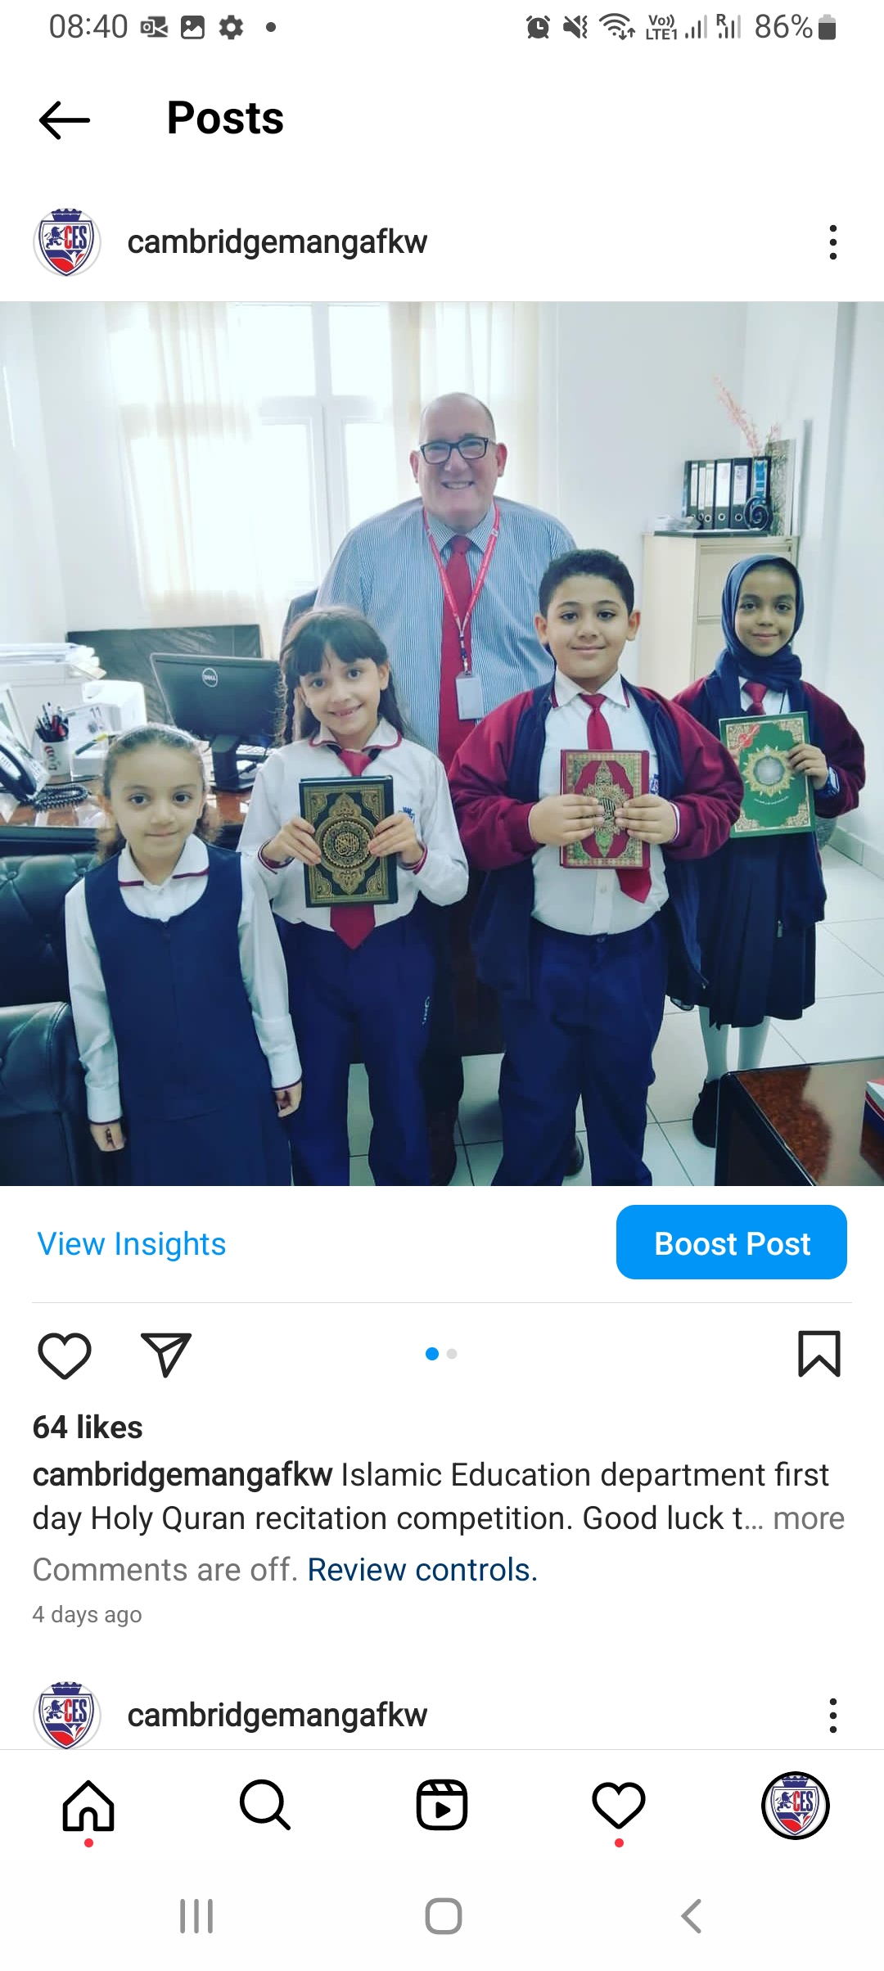

Well done to all the pupils who were involved in the Qur’anic Recitation Competition for representing Cambridge English School, Mangaf, organised by the General Administration for Private Education. We thank all the Islamic teachers that were involved in this also. Check out Instagram for more photographs.

**WEEKLY ATTENDANCE**

**CES Mangaf Attendance**

**Target is:**

**100%**

**Congratulations**

**to: Rec Blue, 1 Blue, 2 Blue,**

**2 Red, 4 Green, 5 Red and 10EO for highest class attendance week ending 13.10.2022**

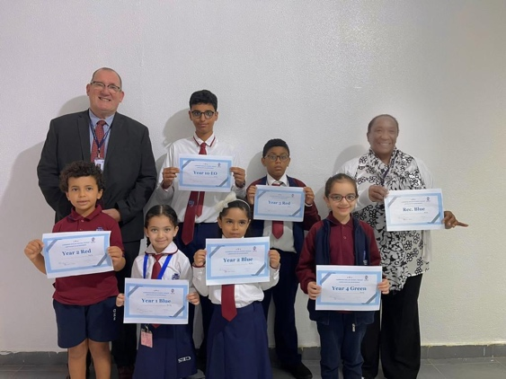

CES Mangaf school Attendance for Week ending: 13.10.2022

**90%**

‘Students achieving their full potential as active thinkers and self-motivated, life-long learners

within a supportive environment’.

**CES NEWS**

**Follow us on Instagram: @Cambridgemangafkw**

**Term: 1 Week: 5 2nd October 2022**

**DATES FOR THE DIARY:**

**Special Assembly:** Thursday 6th October 2022 at 7.15am in the Quad (Pupils only)

**Cancer Awareness Week:** 9th—13th October 2022

**Pink Day: 13th October 2022**. This is a non-uniform day and children can come to school wearing pink or blue to help raise awareness for cancer.

**PRIMARY**

**BULLETON:**

& We want children to love learning in Primary and to enjoy their weekends. This is why we will send homework out on Sundays instead of Thursdays from now on.

& Parents. Do please dedicate some time in the day to read with your child. Just 5 minutes a day can make such a big difference.

**Attendance**

**Target is:**

**100%**

|  |
| --- |
|   **DATES FOR THE DIARY:**  **Colour Yellow Day:** KG and Reception children are invited to wear the colour yellow for the last Thursday of the month so this will be: **Thursday 24th November**  They are welcome to bring in yellow food for their snacks also.    **End of Term 1:** our last day of the term will be **Thursday 15th December 2022.**  A group of children posing for a photo  Description automatically generated with medium confidence  A message from:  **Ms. Aya**  Headteacher of Primary    Dear all, it has been a great week this week with lots of activities and important messages shared about anti-bullying. Parents, please support us by reminding our children that the best way to combat the issue of bullying is to help our children be better, kinder and caring friends to all.  It has been lovely to see all the posters, to watch all the assemblies and I am proud of all the children who participated in the special events this week!  A message from:  **Mr. Andy**  Headteacher of Secondary |

](https://www.instagram.com/cambridge.e.s.kw/)



It’s been a very busy week in our secondary school. We have had our anti-bullying week and I was impressed with the hard work of our senior students when they put together their speeches.

We also had our first whole school student council meeting, where members of Primary and Secondary got together to share their ideas about how to improve the school. I was impressed with the way the children contributed and listened to each other’s ideas and look forward to our next meeting. Graphical user interface, text, application, chat or text message

Well done to our senior school basketball team who played a friendly match against a neighbour school. The team played with passion and enthusiasm, with all team members thoroughly enjoying the game!

**http://www.cambridge-kw.com/**

**Follow us on Instagram: @Cambridgemangafkw**

**Term: 1 Week: 10 10th November 2022**